Solitude: đơn độc

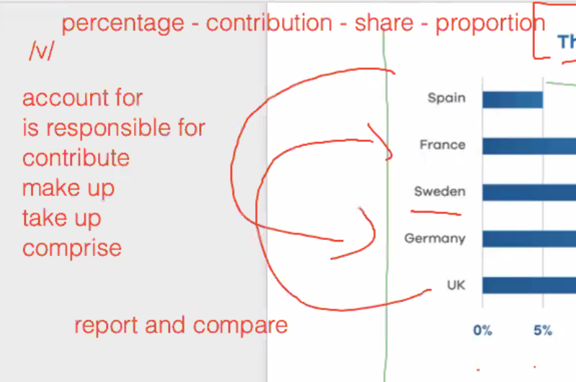

It is believed that providing details of crime scenes in the media should be banned as some people can be affected. This essay will discuss the extend of both perspectives and prove my personal view also.

Firstly, those arguing against the public crime information on media platform point out that the economy is currently in crisis, resulting in increased unemployment and poverty, as well as an increase in robberies and criminal activities. Since the crime news usually have bloody and scaring news, some people have strongly reactions such as vomit and panic when they came a cross any number of this kind of news

In spite of some listing reason above, publishing criminal information should not prohibited. On the other hand, the aim due to some reason. On the other hand, the aim of news related to offenders not only warn people to the danger but also prevent incipient criminals. If the police public those on the TV, the local people shall have more security method to protect their estate. Furthermore, it help to scare people who intend to break the law and they need to think more times before committing crime. However, in order to avoid some bad scenario in first part, this news should be broadcast on some unique channels for who want to see related criminal news.

While the pointing that against the public crime information on mass media have some reason in some situation, I am of the opinion that publishing crime information are far more significant.

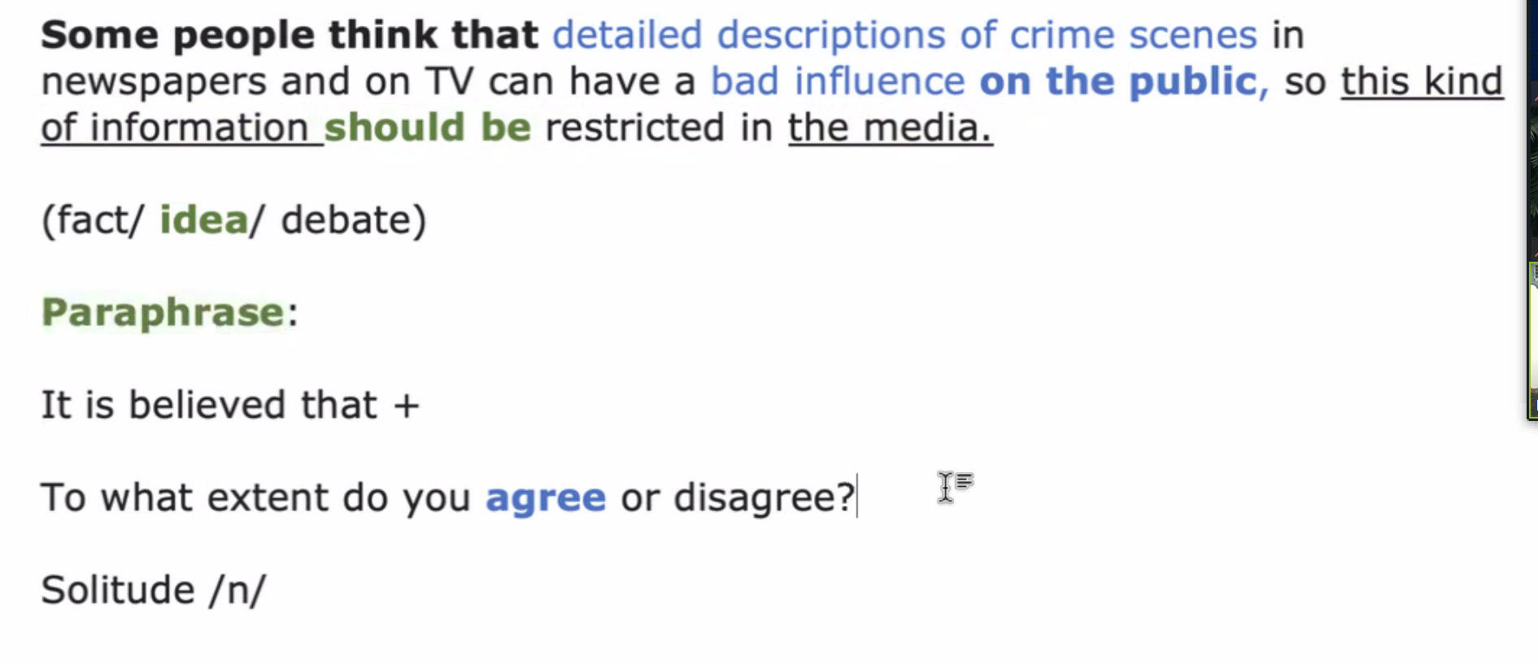

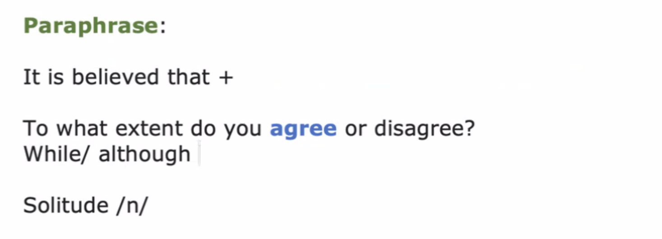

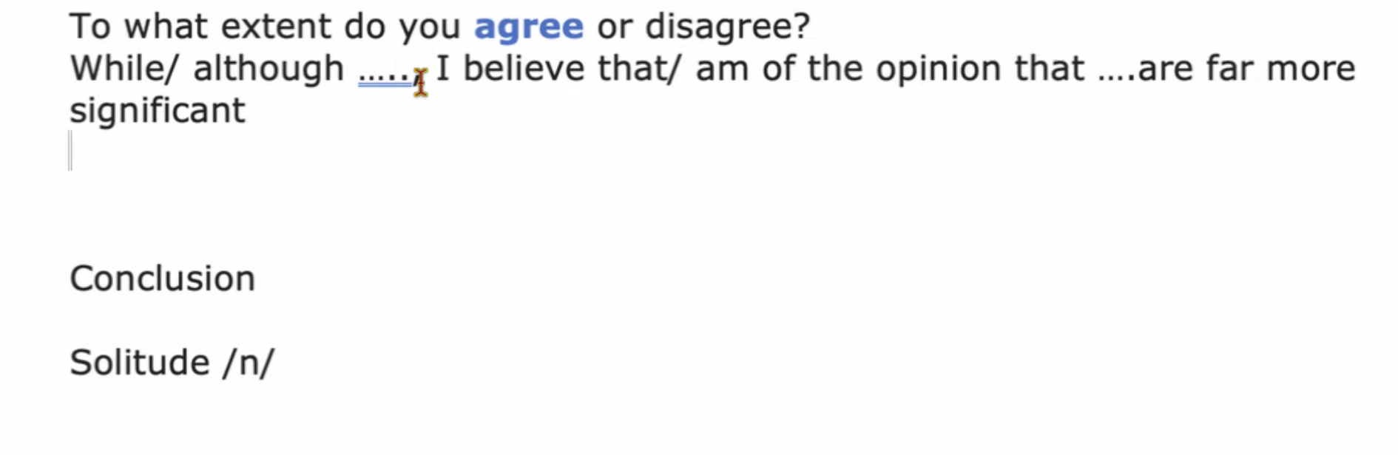

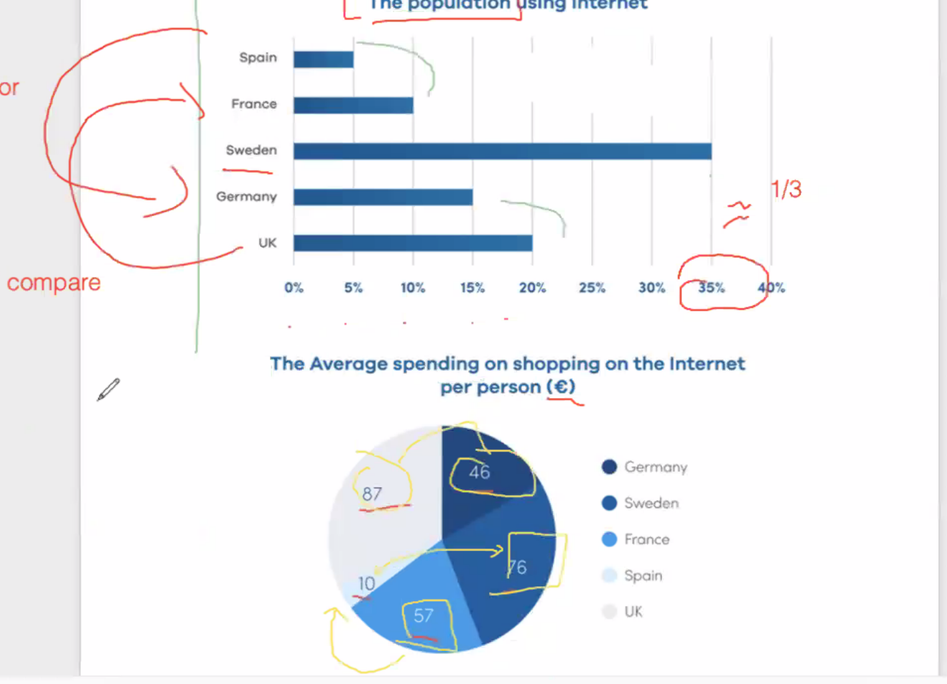

The charts below compared the use of Internet in five nations in Europe in 2000. Overall, the **population using Internet in Sweden is** highest compared to other nation. However, the average spending on shopping on the Internet in UK is highest.

Regarded to the population using internet, Germany is accounted for 15% twice as much as Spain at 5%. In addition, the population using internet in France is a half of those in UK, being 10% and 20% respectively. Sweden is responsible for 35% in the population using internet.

When it comes to the average spending on shopping on the Internet per person, the average spending in UK is approximately double the average spending in Germany, at 87% and 56% correspondingly. In Sweden, the average spending on shopping online eight times as much as Spain, with 76 euro and 10 euro in turn. The average amount spent per person on internet shopping in France is 57 euro.